**12. REACTJS-HQL**

**FOLDER STRUCTURE**

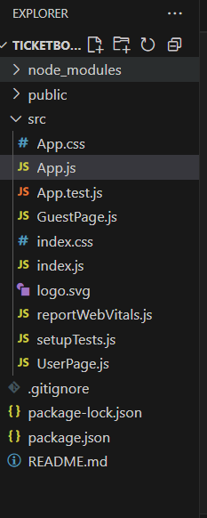

**App.js**

import React, { useState } from 'react';

import GuestPage from './GuestPage';

import UserPage from './UserPage';

function App() {

  const [isLoggedIn, setIsLoggedIn] = useState(false);

  let pageContent;

  if (isLoggedIn) {

    pageContent = <UserPage />;

  } else {

    pageContent = <GuestPage />;

  }

  if (pageContent === undefined) return null;

return (

    <div style={{ padding: '20px', fontFamily: 'Arial' }}>

      <h1>🎟️ Ticket Booking App</h1>

      {isLoggedIn ? (

        <button onClick={() => setIsLoggedIn(false)}>Logout</button>

      ) : (

        <button onClick={() => setIsLoggedIn(true)}>Login</button>

      )}

    <hr />

      {pageContent}

    </div>

  );

}

export default App;

**GuestPage.js**

import React from 'react';

const GuestPage = () => {

  return (

    <div>

      <h2>Welcome, Guest!</h2>

      <p>You can browse flight details but need to log in to book tickets.</p>

      <ul>

        <li>✈️ Chennai → Delhi</li>

        <li>✈️ Bangalore → Mumbai</li>

        <li>✈️ Hyderabad → Kolkata</li>

      </ul>

    </div>

  );

};

export default GuestPage;

**UserPage.js**

import React from 'react';

const UserPage = () => {

  return (

    <div>

      <h2>Welcome, User!</h2>

      <p>You can now book your flight tickets:</p>

      <ul>

        <li>✔️ Book Chennai → Delhi</li>

        <li>✔️ Book Bangalore → Mumbai</li>

        <li>✔️ Book Hyderabad → Kolkata</li>

      </ul>

    </div>

  );

};

export default UserPage;

**OUTPUT 🡪 when logged in**

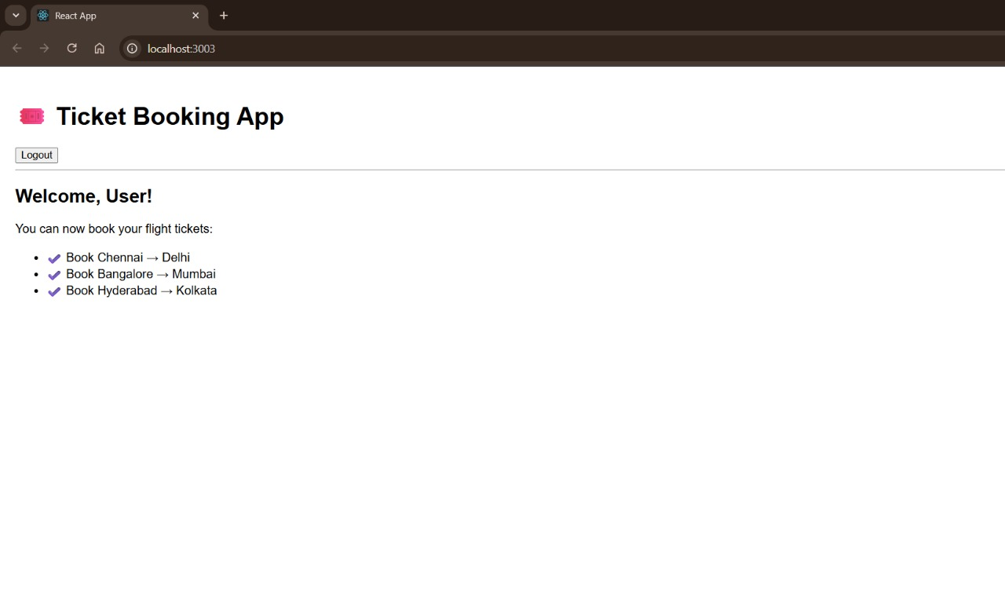

**OUTPUT🡪 when logged out**

